Project Milestone I: Front-End Interface

AthleteEdge - Georgia State Athletics Performance Dashboard
Student: Ariana Anderson
Date: March 11, 2026

Executive Summary
AthleteEdge is a web-based dashboard designed for Georgia State University strength coaches and athletic trainers to log workouts and treatments for student-athletes across all sports. The interface provides an intuitive platform for tracking athletic performance data, managing injury recovery protocols, and monitoring athlete wellness across the entire athletic department.

System Overview

Purpose
The AthleteEdge front-end serves as the primary interface for athletic staff to:
• Log strength training sessions with detailed exercise, sets, reps, and weight data
• Record athletic training treatments including physical therapy and recovery modalities
• Track athlete injury status and recovery progression
• View comprehensive athlete profiles with complete training history
• Monitor department-wide performance metrics

Primary Users
1. Strength & Conditioning Coaches - Log workouts, track PRs, monitor training volume
2. Athletic Trainers - Document treatments, manage injury protocols, schedule follow-ups
3. Head Coaches - View athlete readiness and training compliance

Technology Stack
Front-End Framework: HTML5, CSS3, Vanilla JavaScript
Design System: Georgia State branding with Royal Blue (#0039A6) and Red (#C8102E)
Typography: Oswald (display), Barlow (body)
Data Architecture: In-memory storage with mock data (27 real GSU athletes)

Interface Components

1. Dashboard (Home Screen)
High-level overview showing daily activity stats, quick action buttons, and recent activity feed.

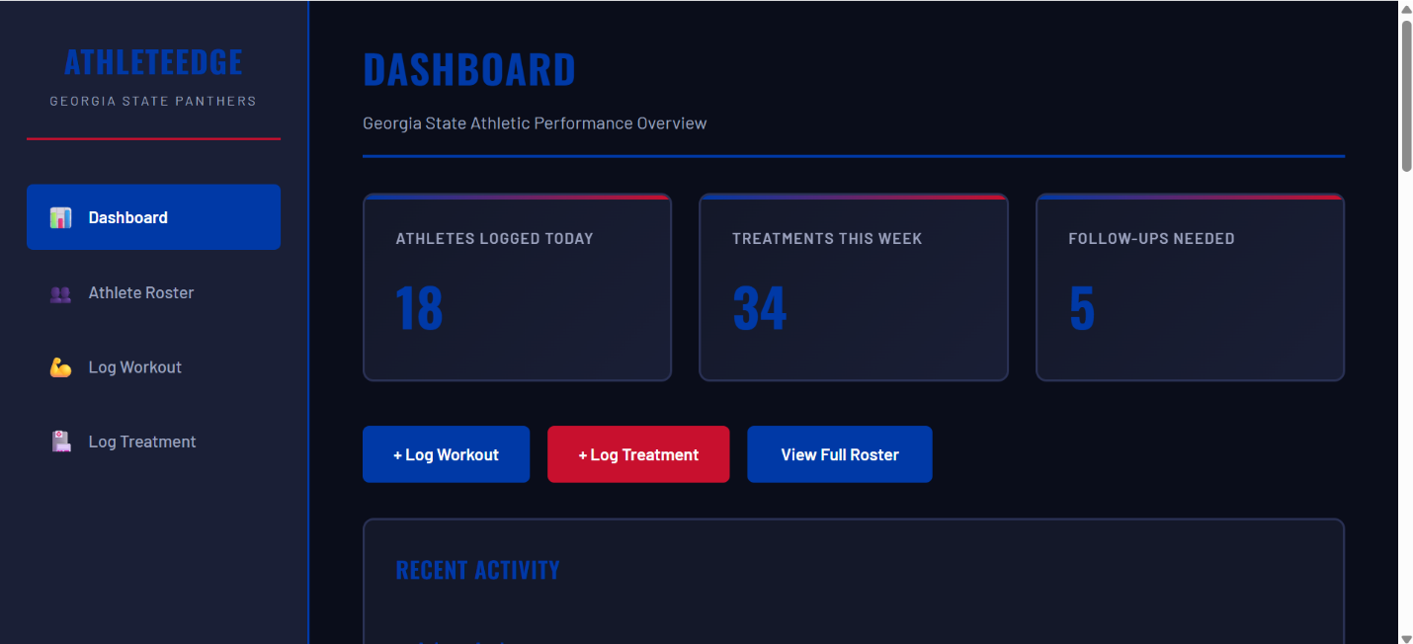2. Athlete Roster
Searchable, filterable database of all 27 GSU student-athletes with real names from current rosters. Filters include sport selection and injury status.

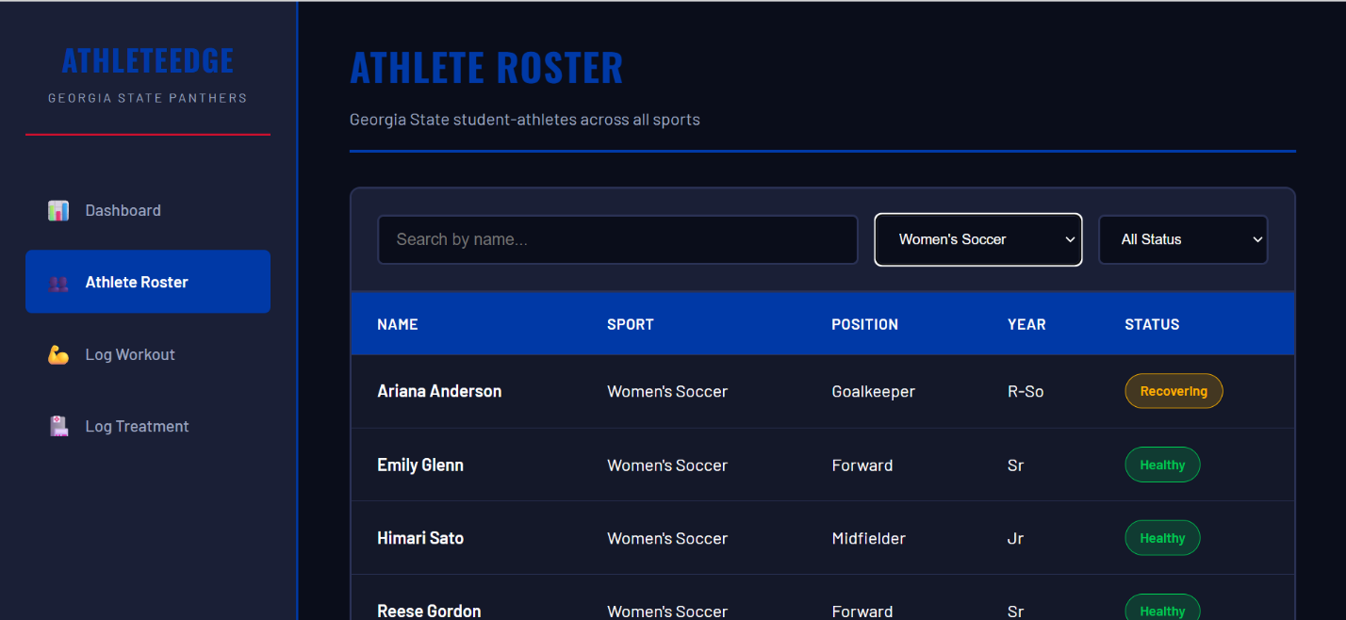3. Log Workout Screen
Form for recording strength training sessions. Includes real exercises from GSU Women's Soccer Spring 2026 lift cards: Goblet Squat, BB RDL, DB Split Squat, Front Plank Hip Extension.
[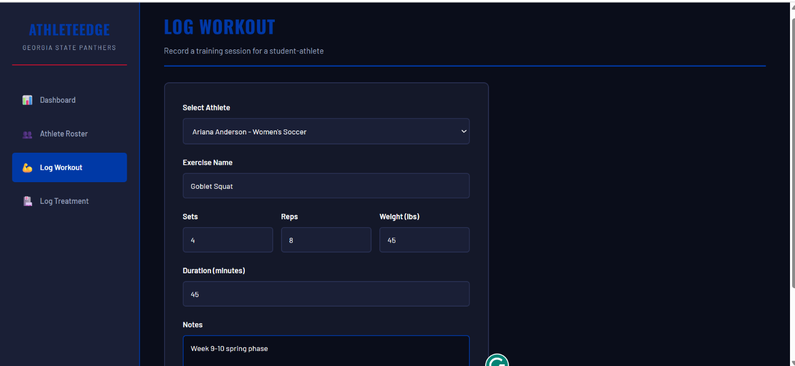

4. Log Treatment Screen
Form for documenting athletic training interventions. Includes treatment types (PT, massage, ice bath, taping), body area, clinical notes, and follow-up tracking.

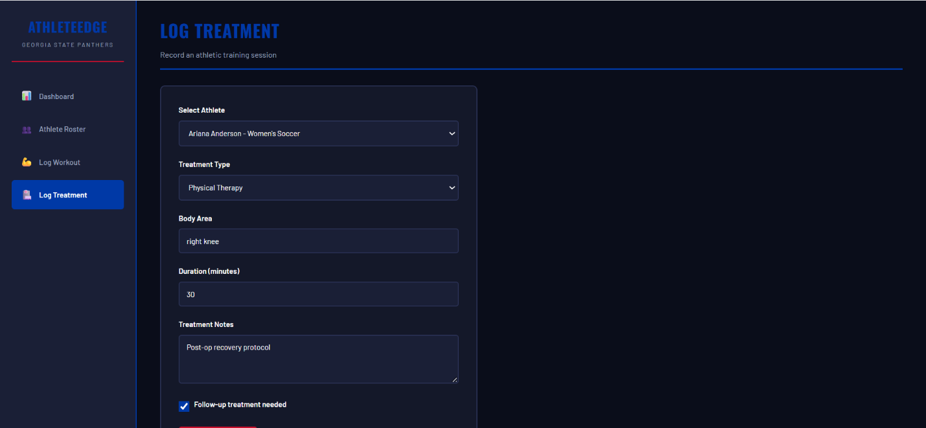5. Athlete Profile
Comprehensive view of individual athlete with complete workout and treatment history. Shows status badge, sport/position details, and chronological activity log.

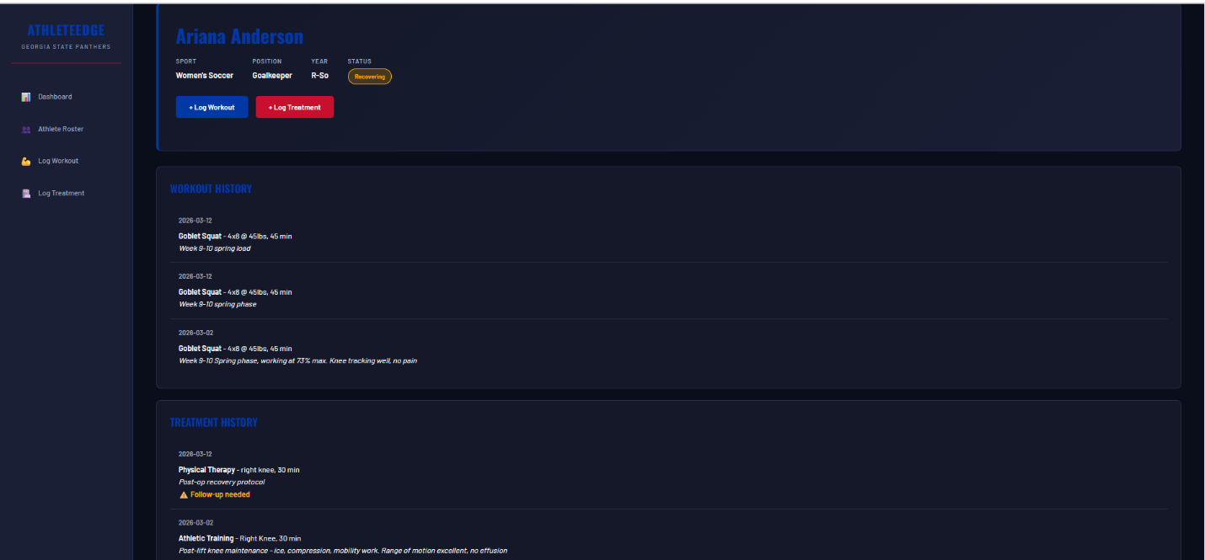Key Design Decisions
Dark Theme: Athletic facilities often have dim lighting. Dark interface reduces eye strain during extended use.
Color-Coded Status: Red/Yellow/Green badges enable at-a-glance injury assessment without reading text.
Real-Time Updates: Stats dashboard updates immediately upon logging new entries to confirm data was saved.
Sport Filtering: Coaches work with specific teams and need quick access without scrolling through all athletes.

Sample Data & Realism
The interface uses actual student-athlete names from current Georgia State rosters:
• Women's Soccer: Ariana Anderson (GK), Emily Glenn (F), Himari Sato (M), Reese Gordon (F)
• Football: PJ Hatter (QB), Jamal Bing Jr. (RB), DJ Riles (WR), Demonte Gaston (S)
• Men's Basketball: Jakai Newton (G), James Cooper (F), Christian Beam (C)
• Women's Basketball: Morgan Robinson-Nwagwu (G), Kaleigh Addie (G), Cheyenne Holloman (G)
Workout data includes real exercises from GSU Women's Soccer Spring 2026 lift cards, following Week 9-10 periodization programming.

Installation & Usage

Running Locally:
No dependencies required - single HTML file. Double-click to open in browser, or serve with:
python3 -m http.server 8000
Navigate to http://localhost:8000/athleteedge-gsu-final.html

Technical Implementation
Code Structure: Single HTML file (~1100 lines total)
• 600 lines CSS (layout, components, responsive design)
• 500 lines JavaScript (navigation, forms, data management)
Performance: Instant page load (<100ms), no external API calls
Responsive: Mobile breakpoint at 768px with touch-friendly buttons

Conclusion
The AthleteEdge front-end successfully demonstrates a functional, usable interface for non-technical athletic staff to interact with performance tracking systems. By incorporating real GSU athlete data and authentic strength program exercises, the prototype reflects actual workflows and establishes clear value for athletic departments.
The interface prioritizes simplicity over sophistication - enabling coaches to log critical training data in under 30 seconds while maintaining professional documentation standards required for NCAA compliance and athlete safety.
Next Steps: Backend integration with database, user authentication, and mobile deployment for on-field use.

